**Personal Information:**

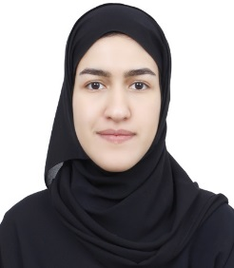

|  |  |
| --- | --- |
| Full Name: | Balqees Salman Abdulla Al-Nashaba |
| Address: | H: 2468, R: 3453, B: 334, Manama |
| Nationality: | Bahraini |
| Date of Birth: | 25/01/1994 |
| Gender: | Female |
| Marital Status: | Married |
| CPR Number: | 940108224 |
| Contact No.: | +973 35315387 |
| Email Address: | Balqoosa_94@hotmail.com |

**Educations:**

|  |  |  |  |  |
| --- | --- | --- | --- | --- |
| University / Institute | From | To | Major | Program |
| AMA University | Jan 2014 | Exp. On the end of 2019 | Business Informatics | Bachelor of Science |
| Omaima Bint Al-Nuaman Secondary Girls school | Sep.2008 | June 2011 | Commercial Secondary Certificates | High school Graduate |

# Skills:

|  |
| --- |
| Technical: - MS Office application- Internet. -The ability to work with any other applications. |
| Interpersonal:   * Business Management and administration * Able to communicate well * Interpersonal Skills * Self-motivated * Leadership Skills * Committed and punctual |
| Language:   * Arabic (Native) * English (Fluent) |

# Hobbies and interests:

* Travelling
* Technology
* Sports

**References:**

**Available upon request.**

**🕮 All documents will be available upon request.**